***INDUSTRIAL TRAINING REPORT:***

*CARA(Web-development project)*

Student Name: **GAURAV BHARDWAJ**

Group: **5ITE2 (20-24)**

Enrollment No.: **02514813120**

HOD (ITE): **Dr. Amita Goel**



Maharaja Agrasen Institute of Technology,

PSP Area, Sector – 22, Rohini,  
 New Delhi – 110085

**INDEX**

|  |  |  |
| --- | --- | --- |
|  |  |  |
| S no. | **Contents** | **Page No.** |
| 1. | Acknowledgement | 1 |
| 2. | Declaration | 2 |
| 3. | Certificate of completion | 3 |
| 4. | Introduction | 4 |
| 5. | Company Information | 5 |
| 6. | Product Overview | 7 |
| 7. | Software Requirements and Specifications | 8 |
| 8. | Technology | 9 |
| 9. | Data Analysis | 11 |
| 10. | Snapshots | 12 |
| 11. | Conclusion | 17 |
| 12. | Bibliography | 18 |

**ACKNOWLEDGEMENT**

First, I would like to thank Mr. **Pranav Pai Vernekar**, co-founder, **Bolt IoT** under whose mentorship I completed my web development training.

It is indeed with a great sense of pleasure and immense sense of gratitude that I acknowledge the help of all the individuals who helped me during my training.

I am extremely great full to my department staff members and friends who helped me in successful completion of this internship.

GAURAV BHARDWAJ B. Tech (5ITE 2) (02514813120)

**DECLARATION**

I, **Gaurav Bhardwaj**, hereby declare that this project is being submitted in fulfilment of the Industrial Training in **BOLT**, and is result of self-done work carried out by me under the various guidelines of engineers and other officers.

I further declare that to my knowledge; the structure and content of this project are original and have not been submitted before.

GAURAV BHARDWAJ B.Tech (5ITE 2) (02514813120)

CERTIFICATE OF COMPLETION



**INTRODUCTION**

**History of Web**

Tim Berners-Lee created HTML in late 1991 but didn't release it officially. He published  it later in 1995 as HTML 2.0. The idea behind creating the Web was to create a service  that helps everyone communicate, share, and receive information. Then came HTML 4  which served as a major version of HTML. HTML has evolved very much and received  various updates since its creation. With each version, the creation of webs got easier  and stylish. HTML is generally used to design the basic structure of the webs, which  will be then improved using other technologies like CSS and JavaScript. CSS controls the  looks, feel, layout and formatting, whereas JavaScript is used to control different  elements' behaviour on the .

**Front end and Back end**

There are two faces of a website: front-end and back-end. These are the most popular and  crucial topics in web development.

Front-end: The front-end is the part of a website with which the users interact directly.  It's also called the ‘client-side’ of a website. It includes everything the users see: text,

colors, styles, images, buttons, menus, etc. HTML, CSS, and JavaScript are the tools  generally used for frontend development. Front-end developers build the front-end part of  a website. Being a front-end developer, you will have to ensure that your websites look  good on all devices for a smooth user experience. There are many front-end frameworks  and libraries which developers use, like React.js, jQuery, Angular.js, etc.

Back-end: Back-end is the server-side of a website. A back-end web-developer uses it to  store and manage data and make sure that the client-side of the website works without  any issues. The website's users or clients cannot see and interact with the back-end part of  a website. The backend part of the software is abstracted from the users. Every line of  code you write for the backend will be used on the frontend side anyways. In simple  words, we can say that everything that happens in the background can be credited to the  backend. Like frontend, there are many backend libraries that developers use like  Express, Rails, Django, etc.

**COMPANY INFORMATION**

BOLT IoT is a start-up based company out of India with its head offices in Bengaluru and Mumbai. BOLT’s products are:

1. Bolt IoT and ML Platform: a fully integrated IoT platform for developers that helps them to built IoT projects and products quickly and easily.
2. Blake: An enterprise temperature and humidity monitoring solution

Bolt also offer popular training on topics like IoT and ML, Robotics, Voice Apps, Web Development, Augmented reality etc for the users to get started with building projects. Bolt has users across 62 different countries with more than 40,000 units of hardware module shipped.

**Objective of Industrial Training**

Industry training is a major component of the extra-curricular learning in engineering.  The students are required to pass before the Industrial Training is recommended for

award of a degree at any engineering college. The students will be placed in government  departments or private companies for 6 weeks to expose them to a real work environment  and different from the atmosphere at the college.

Often students will be faced with many challenges and problems that have not been  confronted. The main purpose of this training was to expose students to the real working  environment when the students leave the college later.

Students also have the opportunity to use all the knowledge and theories related to courses taken while at the engineering course of industrial training and provide opportunities for  students to use the fruit of a creative mind for the good of the firm and indirectly for their  own benefit as well. Thus, there has been this experience, maybe it can help students to  study in the following semester and a real working environment. Students also can be  exposed to ways to communicate well, expanding relationships between partners of the workplace and the people around, foster teamwork and good relations with industrial workers where this at once can cause a sense responsible to a trust (work) and balance as  well as from all aspects.

For example, one kind of algorithm is a classification algorithm. It can put data into different groups. The classification algorithm used to detect handwritten alphabets could  also be used to classify emails into spam and not-spam. In addition, following the  Industrial Training, students can improve their own weaknesses to improve and think  more rationally in the handle which had been given by the employer. In the course of  industrial training, students can assess their ability to work from employers. The students  themselves can infuse the spirit of productivity to the challenges and obstacles that lie  ahead.

Hopefully with the Industrial Training which is able to run to enhance the knowledge of  students to enable them to contribute more effectively towards national development in  the future and also to get a job that suits them according to the skills they have learned. In conclusion, the objective of the training period is to:

• To expose students to the real working environment.

• Let’s students see the connection between theoretical learning with practical work. • Adopt and comply with safety regulations in the industry.

• Establish and strengthen confidence in the performance of duties. • Instil teamwork and good relationships with other employees.

• Ability to assess themselves to prepare for the working world after graduation.

• Raise awareness and increase student interest in the subject selected.

• Uplifting honest, trustworthy, dedicated and responsible for the tasks assign.

**PROJECT OVERVIEW**

The advancement in technology is working at the expansion in the structure of e-Commerce. Therefore, that is why the introduction of the Marketplace within the e-Commerce sector can be a path to advancement.

It will permit customers to interact with sellers through a single platform. Therefore, The E-commerce web applications provides both customer-centric and seller-centric features. It also enables the efficient selling and purchasing of products.

These web apps can have an enormous impact on the fashion industry since it serves as a single platform for a variety of brands. Anyone who is awed by fashion and style must remain informed about the latest trends in the world market. Apps such as Cara offer the chance for both the designers and the manufacturer designers to engage directly with the public.

I have come up with my website, ***CARA***that enables users to purchasing different brands of clothes without moving an inch. They can easily just sit around and do shopping both at the same time. The users are provided with all sorts of trending articles. The articles are not only trending but are also cheaply available, users can easily apply coupons on their favourite articles and can get those at the lowest ever price.

**MODULE DESCRIPTION**

1) Starts with the home page showing all the features, latest arrivals and best discounts available

2) The users through shop section can choose from a variety of clothes.  
3) In the blog section the users can read about new trends in the society.  
4) The site through the about us section provide brief description about the website.  
5) The contact section of the website provides all the contact details about us in case of any querry

7) In the cart section we can see all of our favourite collection that we have added to the cart.

**SOFTWARE REQUIREMENTS**

**SPECIFICATIONS**

**System configurations**

The software requirement specification can produce at the culmination of the analysis task. The function and performance allocated to software as part of system engineering are refinedby established a complete information description, a detailed functional description, a representation of system behavior, and indication of performance and design constrain, appropriate validate criteria, and other information pertinent to requirements.

**Software Requirements**:

* Operating system : Windows /Mac OS/ Linux.
* Coding Language : HTML, CSS, JavaScript
* Front-End: Visual Studio code

**Hardware Requirements**:

* System: Intel i3 or greater, Radeon, Ryzen 7
* Hard Disk: 512 GB
* Ram: 6 GB

**TECHNOLOGY**

**HTML**

HTML, or Hypertext Markup Language, is a markup language for the web that defines the structure of web pages. It is one of the most basic building blocks of every website.

To understand "HTML" from front to back, let's look at each word that makes up the abbreviation:

**Hypertext**: text (often with embeds such as images, too) that is organized in order to connect related items.

**Markup**: a style guide for typesetting anything to be printed in hardcopy or soft copy format

**Language**: a language that a computer system understands and uses to interpret commands.

HTML determines the structure of web pages. This structure alone is not enough to make a web page look good and interactive. So you'll use assisted technologies such as CSS and JavaScript to make your HTML beautiful and add interactivity, respectively.

**CSS**

Cascading Style Sheets(CSS) is a stylesheet language used to describe the presentation of a document written in HTML or XML. CSS describes how an element should be rendered on screen, on paper, speech or on other media.

CSS is among the core languages of the open Web and standardise across the web browsers according to W3C specifications. Previously the development of various parts of CSS specification was done synchronously, which allowed the versions of the latest recommendations. You might have read about CSS1, CSS 2.1 or even CSS3 there will never be CSS3 or a CSS4; rather, everything is now CSS without a version number. After CSS 2.1 the scope of the specifications and the progress on different CSS module started so much that it became more effective to develop and release recommendations separately for module instead of versioning the CSS profile vacations W3C now periodically take a snapshot of the latest stable state of CSS specifications and individual modules progress CSS modules now have version numbers or levels such as CSS colour module level 5.

**JavaScript**

JavaScript is a lightweight, interpreted or just-in-time compiled programming language with first class functions while it is most well-known as a scripting language for webpages, many non-browser environments also use it, such as Node.js, Apache and Adobe Acrobat. Java is a prototype based multi-paradigm, Single threaded dynamic language supporting object oriented, imperative and declarative styles. The standards of the JavaScript our ECMS script language specification and a ECCM script inter-nationalisation API specification. As soon as one browser implements a feature, we try to document it this means that cases where some proposals for new ECMA Script features have already been implemented in browsers documentations and examples and MDN articles may use some of those new features. Most of the time this happens between the stages3 and 4 and is usually before the pack is officially published.

Do not confuse JavaScript with the Java programming language. Both Java and JavaScript are trademarks or registered trademarks of a record in US and other countries. However the two programming language have different set index semantics and syntax, semantics and use.

**VISUAL STUDIO CODE**

**Visual Studio Code** is a source-code editor made by Microsoft for Windows, Linux and macOS. Features include support

for debugging, syntax highlighting, intelligent code completion, snippets, code refactoring, and embedded Git. Users can change the theme, keyboard shortcuts, preferences, and install extensions that add additional functionality.

Microsoft has released most of Visual Studio Code's source

code on GitHub under the permissive MIT License, while the releases by Microsoft are proprietary freeware.

In the Stack Overflow 2021 Developer Survey, Visual Studio Code was ranked the most  popular developer environment tool, with 70% of 82,000 respondents reporting that they use it.

Visual Studio Code was first announced on April 29, 2015, by Microsoft at the2015 Build conference. A preview build was released shortly thereafter.

On November 18, 2015, the source of Visual Studio Code was released under the MIT License, and made available on GitHub. Extension support was also announced. On April  14, 2016, Visual Studio Code graduated from the public preview stage and was released to the Web.

**DATA ANALYSIS**

* There are over **26 million** eCommerce sites across the entire globe, with more and more being created every single day. There are more than **9.5 million** eCommerce sites in the US alone, with more and more being created every single day.
* India stands at the 8th position in the world in eCommerce market having a business of whooping $68 billion.

The top **10** largest eCommerce markets in the world are:

* China: **$2,779 billion**
* USA: **$843 billion**
* United Kingdom: **$169 billion**
* Japan: **$144 billion**
* South Korea: **$121 billion**
* Germany: **$102 billion**
* France: **$80 billion**
* India:**$68 billion**
* Canada: **$44 billion**
* Spain: **$37 billion**

The online fashion retail market share in India is expected to increase by USD 22.97 billion from 2021 to 2026, and the market's growth momentum will accelerate at a CAGR of 18.83%.

**Key Online Fashion Retail Market Trend in India**

**Another key factor driving the online fashion retail market growth in India is the rise of social commerce**. As of 2021, India had around 350 million Facebook users, among which 56.8% were male, and 43.2% were female. The social commerce platform facilitates transaction-based social interaction and user experiences. Major players in social media, including Facebook, Instagram, YouTube, Pinterest, and Snapchat, provide opportunities for social commerce through their platforms. Social commerce provides a wide variety of choices, along with shared user experiences and referrals, which eventually impact the decision-making of consumers. It helps retail and e-commerce brands by diverting traffic to their retail websites, increasing their brand reach, and building trust among customers. With the growth of social commerce, the number of e-commerce orders has increased. Such factors will increase the demand for online fashion retail solutions, thereby driving market growth during the forecast period.

SOME SNAPSHOTS OF THE

WEBSITE

Home page:

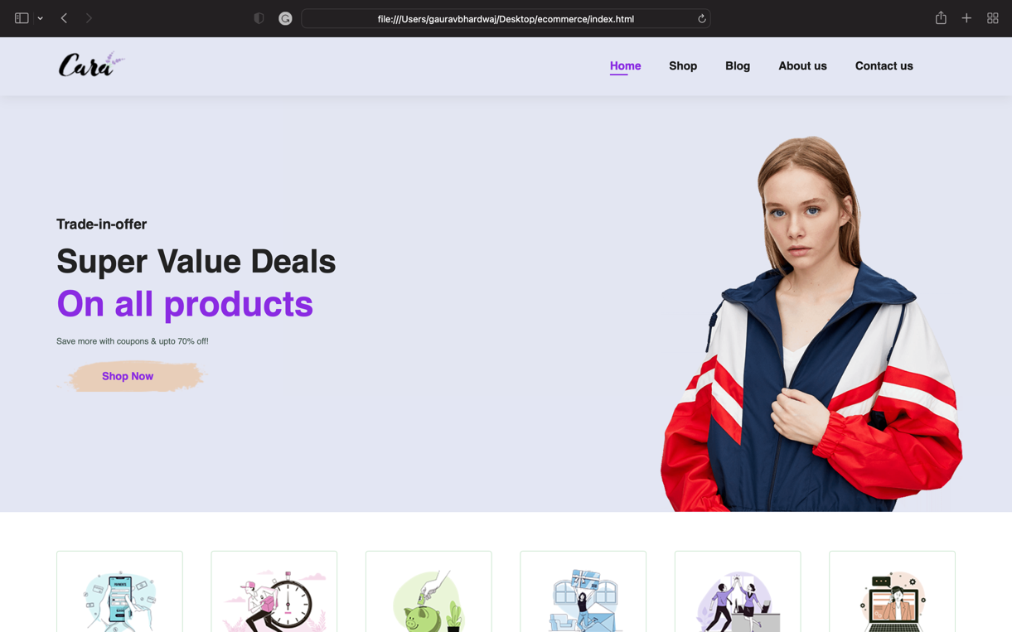

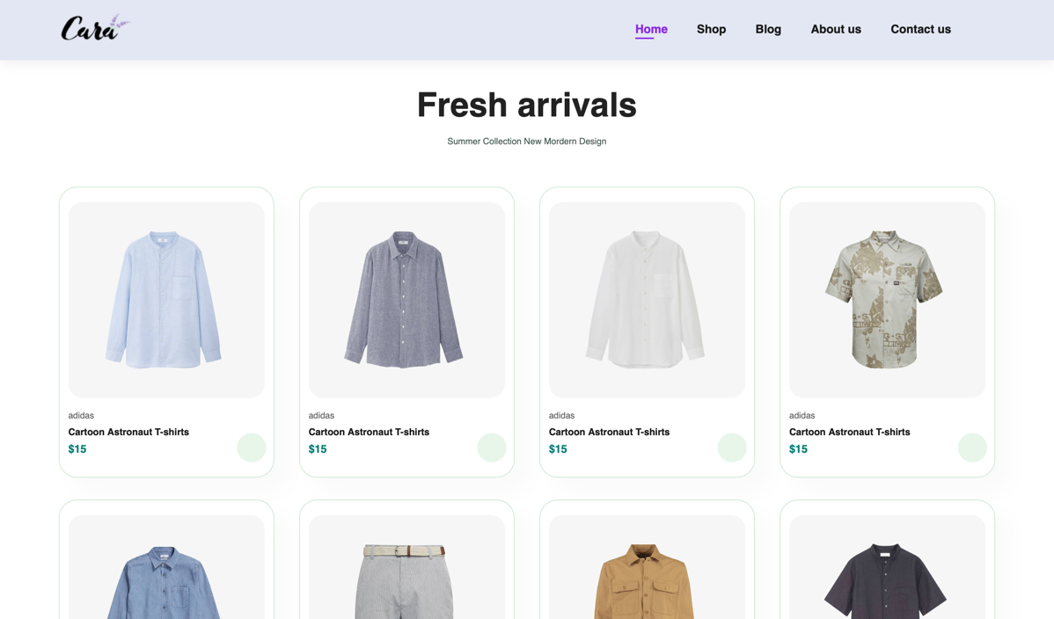

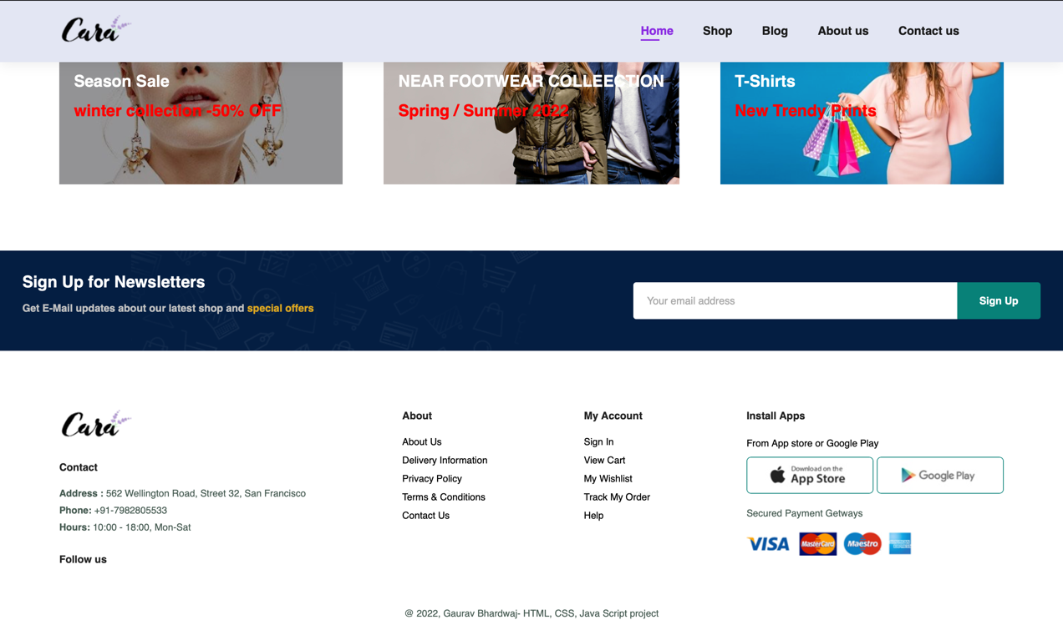

Shop Page:

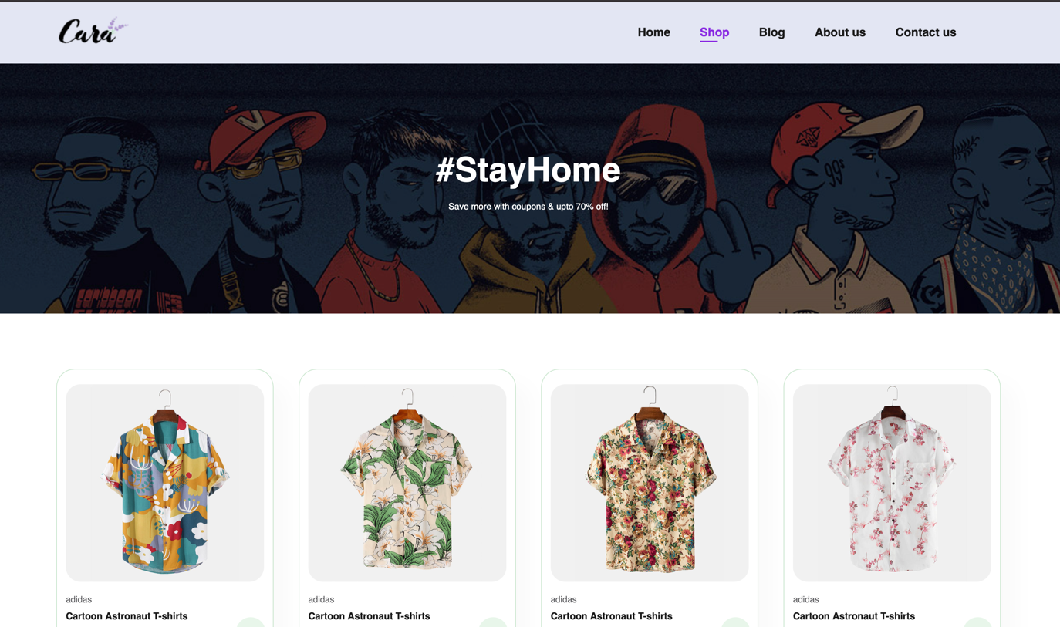

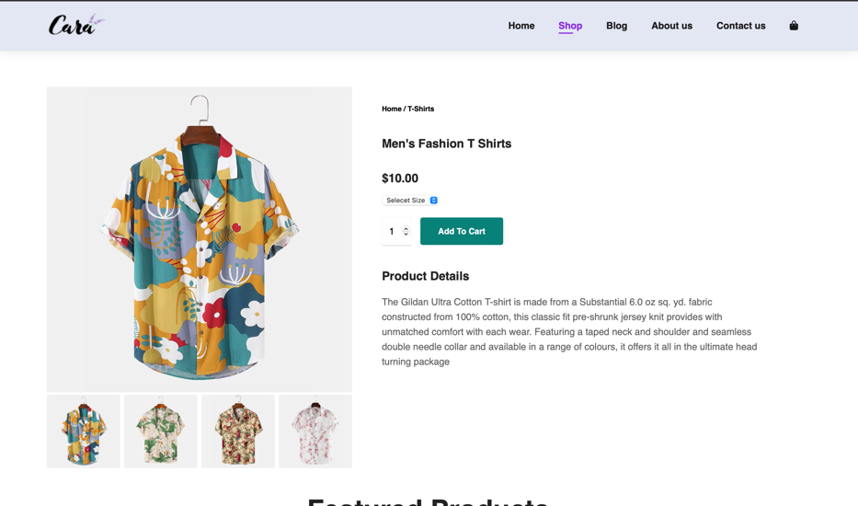

Blog Page:



About Us Page:

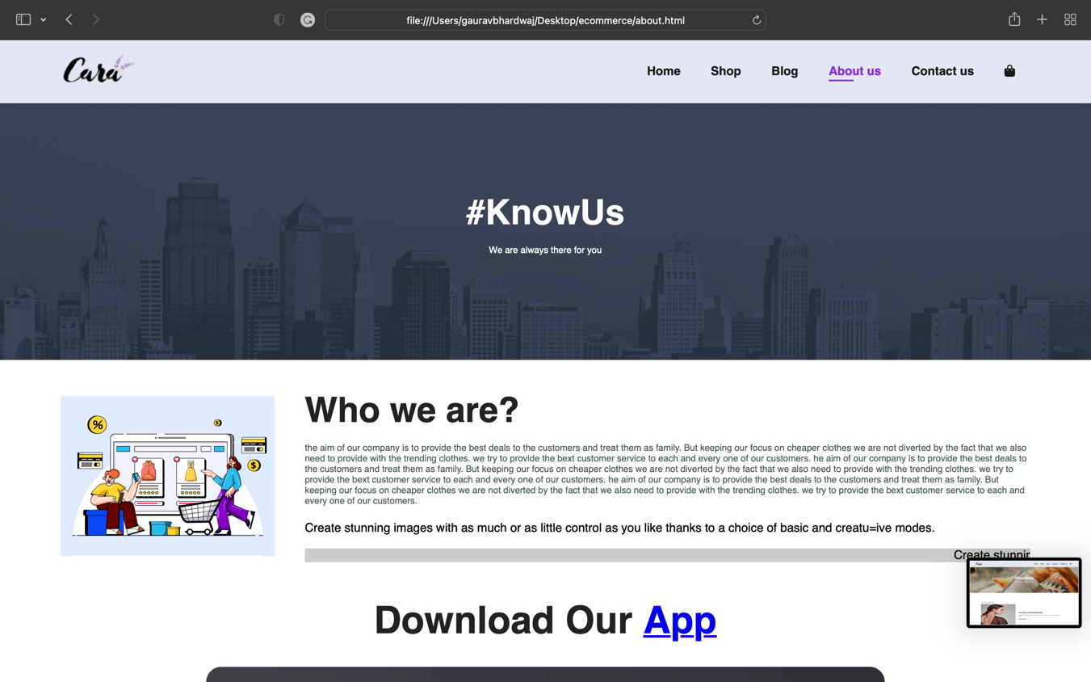

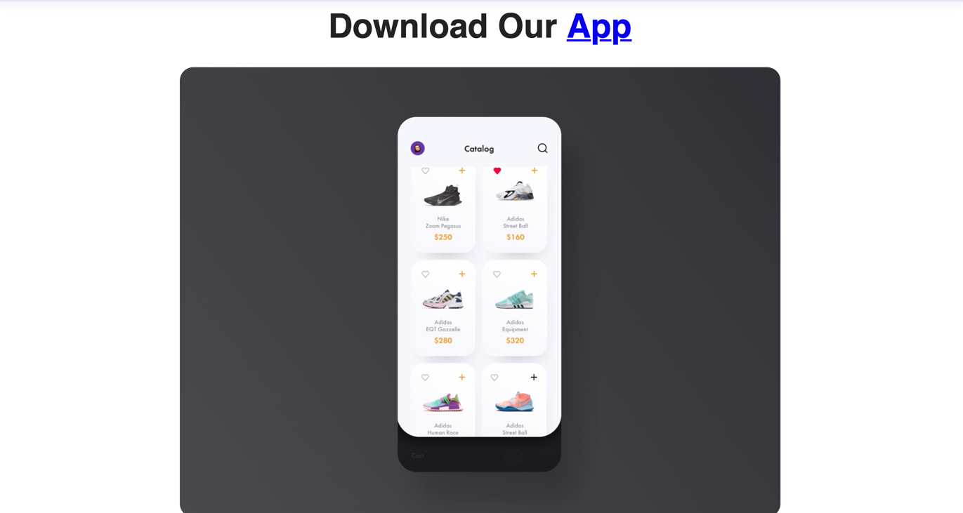

Contact Us Page:

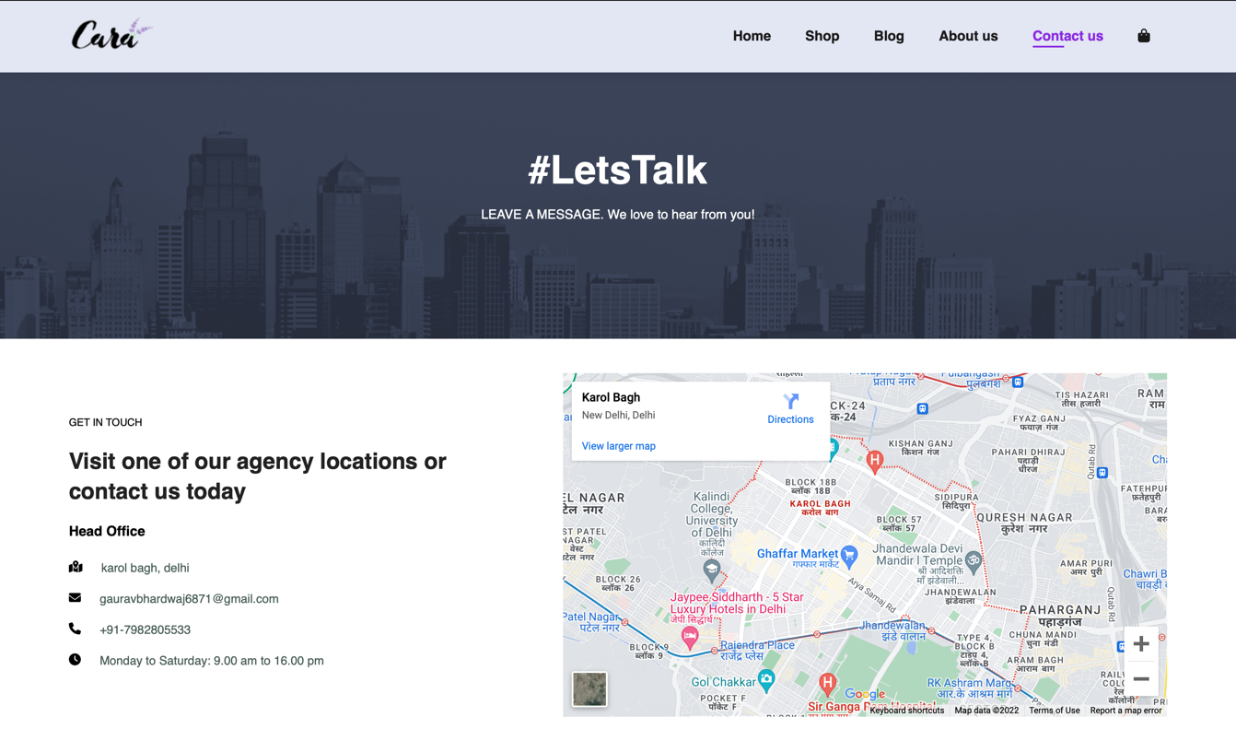

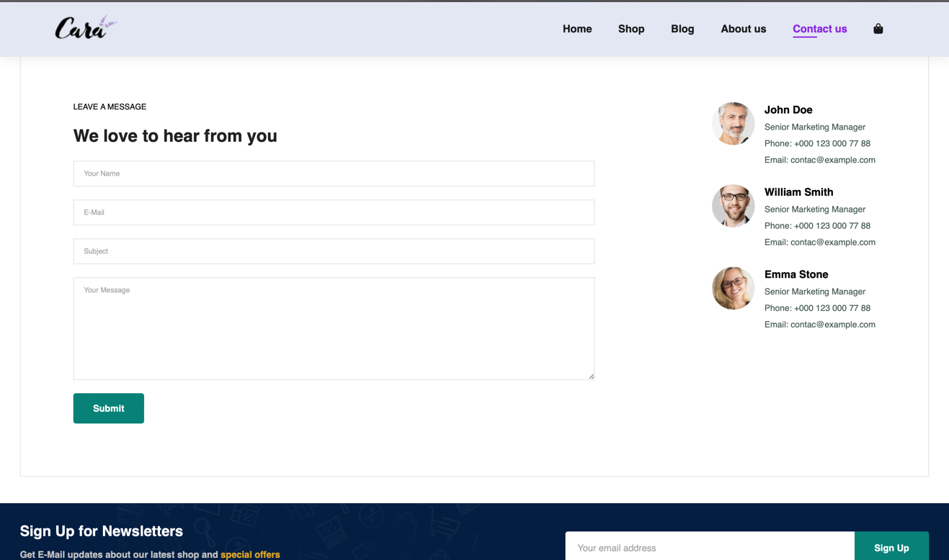

Cart Page:

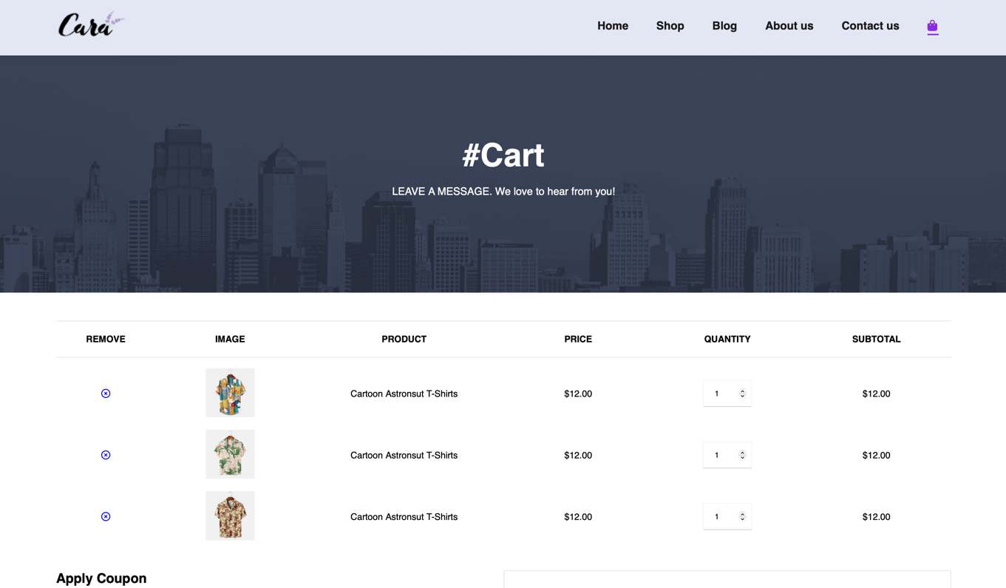

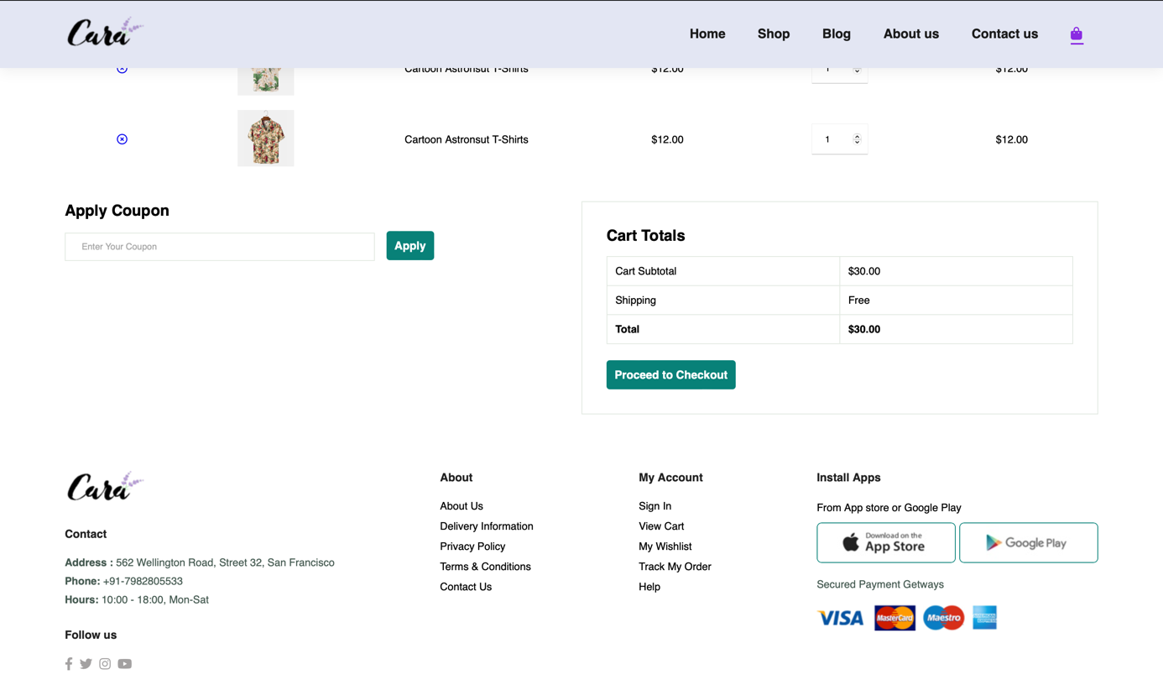

**CONCLUSION**

In a nutshell, this industrial training has been an excellent and rewarding experience.

I can conclude that there have been a lot I have learnt from my time with Bolt IoT, the technical aspects of the work I have done are not flawless and could be improved provided enough time.

As someone with not much experience with web development whatsoever I believe my time spent in research, discovering, and developing it was well worth it and contributed to finding an acceptable solution to build a fully functional application.

Two main things that I have learned are the importance of our time-management skills and self-motivation.

Hope this project achieves its motive that has been framed.

**BIBLOGRAPHY**

The following weblinks are referred during the analysis and execution phase of the project

1. https://www.w3schools.com  
- website for various free tutorials.

2. <https://fontawesome.com/>

-a website providing various icons that can be used in html file

3. https://www.boltiot.com/-

-Took online class from the site